INJURY REPORTING FORM

Reference:__________________________
Full Name: _________________________________ |  |  |  |  |  |  |  |  | DOB: __/__/__ | Gender: M ◻ F ◻ |  | Student / Instructor / Assistant / Spectator
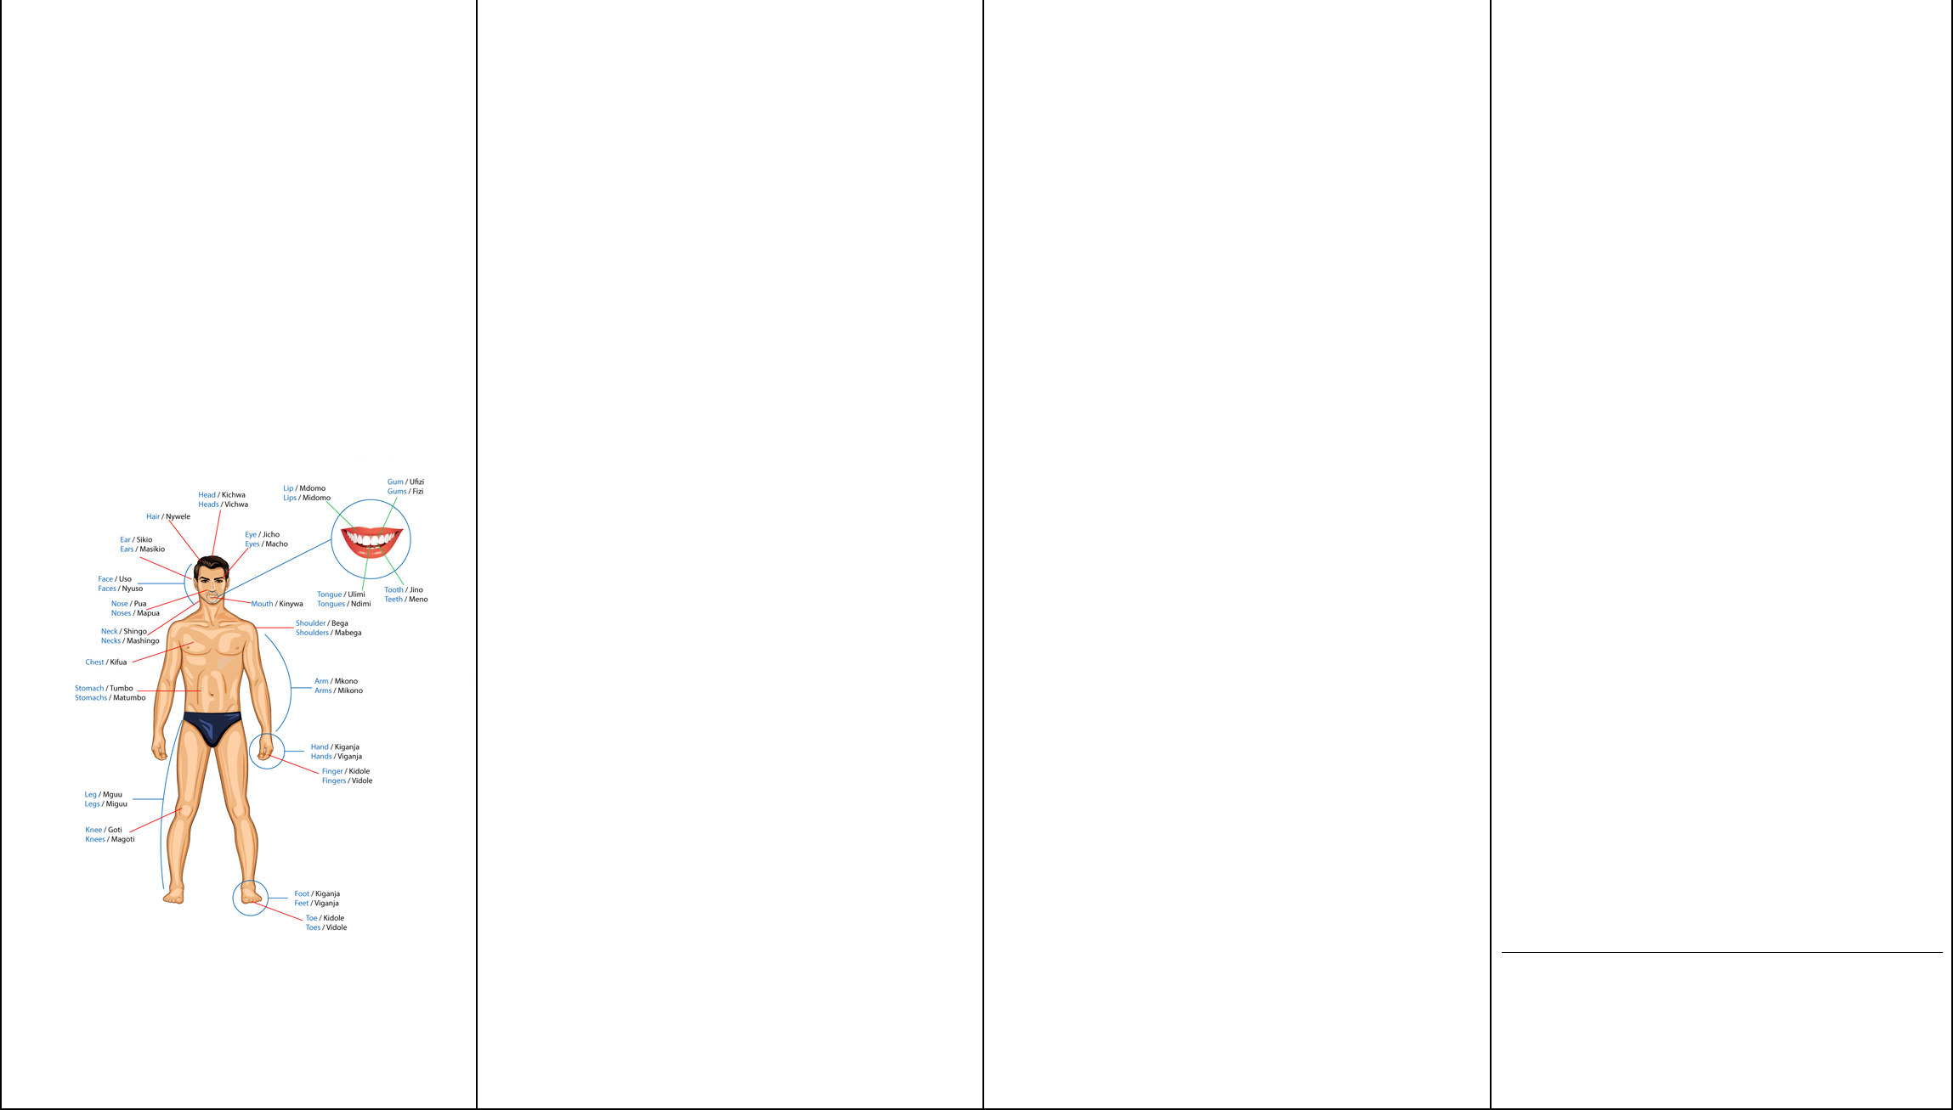  Sport: |  |  |  |  |  |  |  | Style :_________________________ |  | Grade: ___________ |  | Venue/area at which injury occurred: _______________________
Date of injury |  |  |  | / | / |  |  | Nature of Injury/Illness |  |  | Explain exactly how the incident occurred |  |  |  | Advice Given
Time of arrival |  |  |  |  |  |  |  | ◻ abrasion/graze |  |  | (use separate sheet if necessary)  _____________________________________ |  |  |  | ◻ immediate return unrestricted activity
Type of activity at time of injury |  |  |  |  |  |  |  | ◻ sprain eg ligament tear |  |  |  |  |  |  | ◻ able to return with restriction
◻ training/practice |  |  |  |  |  |  |  | ◻ strain eg muscle tear |  |  |  |  |  |  | ◻ unable to return at present time
◻ competition
 |  |  |  |  |  |  |  | ◻ open wound/laceration/cut |  |  |  |  |  |  | Referral
◻ other _________________________ |  |  |  |  |  |  |  | ◻ bruise/contusion |  |  |  |  |  |  | ◻ no referral
Reason for Presentation |  |  |  |  |  |  |  | ◻ inflammation/swelling |  |  |  |  |  |  | ◻ medical practitioner
◻ new injury |  |  |  |  |  |  |  | ◻ fracture (including suspected) |  |  | Were there any contributing factors to the |  |  |  | ◻ physiotherapist
◻ exacerbated/aggravated injury
 |  |  |  |  |  |  |  | ◻ dislocation/subluxation |  |  | incident, unsuitable footwear, playing surface, |  |  |  | ◻ chiropractor or other professional
◻ recurrent injury
 |  |  |  |  |  |  |  | ◻ overuse injury to muscle or tendon |  |  | equipment, foul play? |  |  |  | ◻ ambulance transport
◻ illness |  |  |  |  |  |  |  | ◻ blisters |  |  |  |  |  |  | ◻ hospital
◻ other __________________________ |  |  |  |  |  |  |  | ◻ concussion |  |  | _____________________________________ |  |  |  | ◻ other __________________________
Body Region Injured |  |  |  |  |  |  |  | ◻ cardiac problem |  |  | Protective Equipment |  |  |  | Provisional severity assessment
Tick or circle body part/s injured & name |  |  |  |  |  |  |  |  |  |  | Was protective equipment worn on the injured
 |  |  |  |  |  |  |  | ◻ respiratory problem |  |  | body part? ◻ yes | ◻ no |  |  | ◻ mild (1-7 days modified activity)
 |  |  |  |  |  |  |  |  |  |  |  |  |  |  | ◻ moderate (8-21 days modified activity)
 |  |  |  |  |  |  |  | ◻ loss of consciousness |  |  | If yes, what type eg mouthguard, ankle brace,
 |  |  |  |  |  |  |  | ◻ unspecified medical condition |  |  | taping. |  |  |  | ◻ severe (>21 days modified or lost)
 |  |  |  |  |  |  |  |  |  |  | _____________________________________
 |  |  |  |  |  |  |  | ◻ other __________________________ |  |  |  |  |  |  | Notes
 |  |  |  |  |  |  |  | Provisional diagnosis/es |  |  | Initial Treatment
 |  |  |  |  |  |  |  |  |  |  | ◻ none given (not required)
 |  |  |  |  |  |  |  |  |  |  | ◻ RICE
 |  |  |  |  |  |  |  |  |  |  | ◻ dressing
 |  |  |  |  |  |  |  |  | CAUSE OF INJURY |  |  |  |  |  | Treating person
 |  |  |  |  |  |  |  |  |  |  | ◻ sling, splint
 |  |  |  |  |  |  |  | Mechanism of Injury |  |  |  |  |  |  | ◻ first aider
 |  |  |  |  |  |  |  |  |  |  | ◻ massage
 |  |  |  |  |  |  |  | ◻ struck by other student |  |  |  |  |  |  | ◻ sports trainer – ◻ level 1 ◻ level 2
 |  |  |  |  |  |  |  |  |  |  | ◻ manual therapy
 |  |  |  |  |  |  |  | ◻ struck by weapon or training aide |  |  | ◻ oxygen therapy
 |  |  |  |  |  |  |  | ◻ collision with other student
 |  |  |  |  |  |  |  |  |  |  | ◻ CPR / defibrillater
 |  |  |  |  |  |  |  | ◻ collision with fixed object
 |  |  |  |  |  |  |  |  |  |  | ◻ stretch/exercises
 |  |  |  |  |  |  |  | ◻ fall/stumble on same level
 |  |  |  |  |  |  |  |  |  |  | ◻ strapping/taping
 |  |  |  |  |  |  |  | ◻ grappling or throwing
 |  |  |  |  |  |  |  |  |  |  | ◻ none given - referred elsewhere |  |  |  | Signature of treating person  ____________________________  Printed name of treating person  ____________________________
 |  |  |  |  |  |  |  | ◻ fall from jump /awkward landing
 |  |  |  |  |  |  |  |  |  |  | ◻ other ______________________________

- gradual onset, no specific mechanism
Body part/s | identified | Consumables Used
_________________________________ | ◻ slip/trip |  | Today’s date |  | / /
 | ◻ temperature related eg heat stress
_________________________________ | ◻ other _________________________ |  | Time discharged

Disclaimer – “The information contained in this resource is in the nature of general comment only, and neither purports, nor is intended, to be advice on a particular matter. No reader should act on the basis of anything contained in this resource without seeking independent professional advice from appropriate persons. No responsibility or liability whatsoever can be accepted by us or the authors for any loss, damage or injury that may arise from any person acting on any statement of information contained in this resource and all such liabilities are expressly disclaimed.”

